# DICOM Import/Export Filters

November 14, 2020

K. Dekker

Filters copied over, but they need reconfiguring anyways as they point to the wrong locations and the options were all reset.

# IMPORT FILTERS

## RPM Import

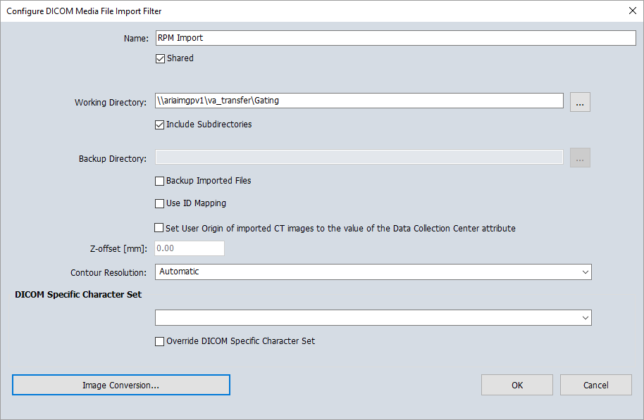

## Import from CT Scanner

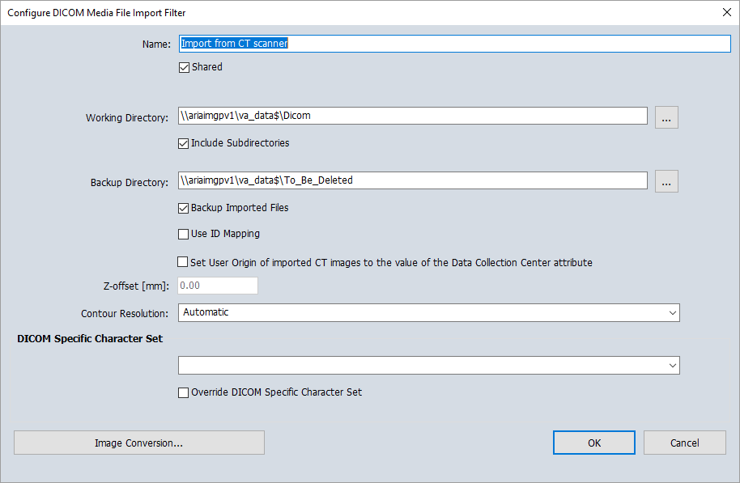

## KGH PACS (Dosimetry Workstations – Individual)

|  |  |
| --- | --- |
| **Service Provider Details** | |
| **AE Title** | ON0693KGDA011 |
| **IP/Hostname** | 138.218.222.109 |
| **Port** | 4100 |
| **Q/R** | Yes |
| **Storage** | Yes |

|  |  |  |  |  |
| --- | --- | --- | --- | --- |
| **Individual Workstation Configurations** | | | | |
| **Computer Name** | **Computer IP** | **AE Title** | **Port** | **Assigned To** |
| ZVAR-IMX-6 | 10.40.62.41 | VWS_Z280 | 50400 | Shelley |
| ZVAR-IMX-11 | 10.40.62.46 | VWS_Z281 | 50400 | Jackie |
| ZVAR-IMX-2 | 10.40.62.42 | VWS_Z282 | 50400 | Jen |
| ZVAR-IMX-9 | 10.40.62.45 | VWS_Z283 | 50400 | Mario |
| ZVAR-IMX-5 | 10.40.62.170 | VWS_Z284 | 50400 | Anne |
| ZVAR-IMX-4 | 10.40.62.194 | VWS_287 | 50400 | Gary |

## Velocity Grid

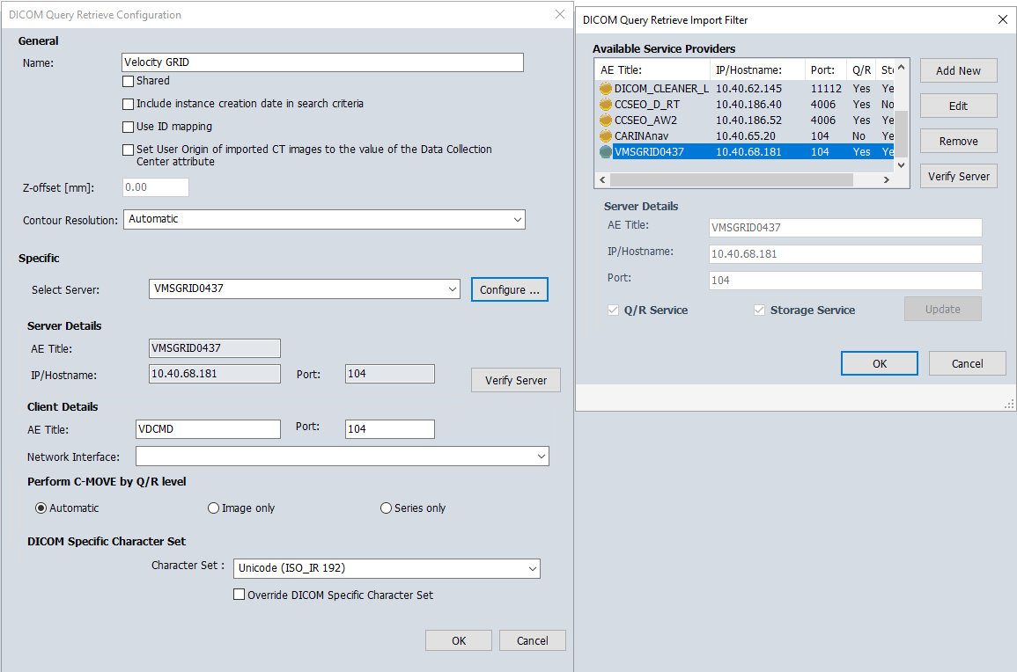

## Import from HDIRS

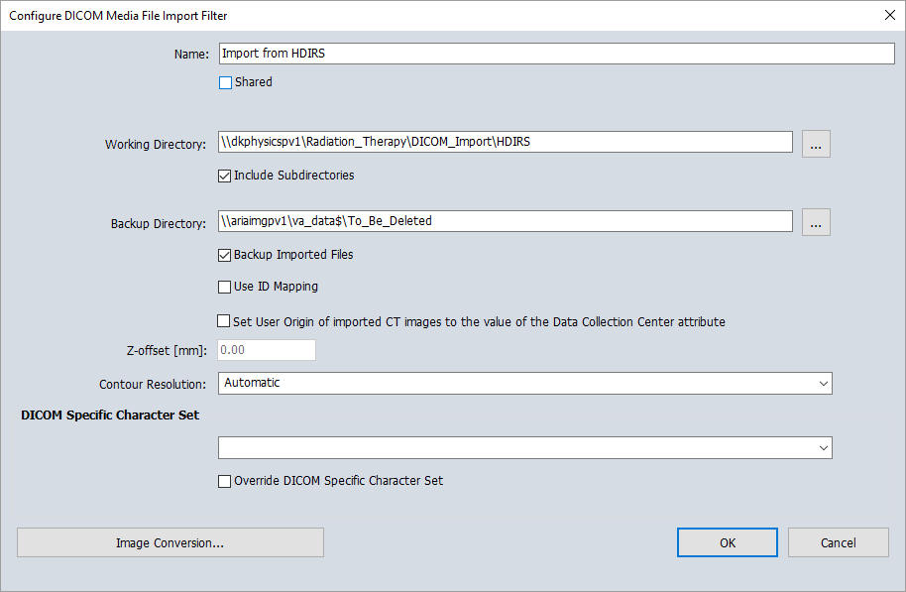

## DICOM Cleaner

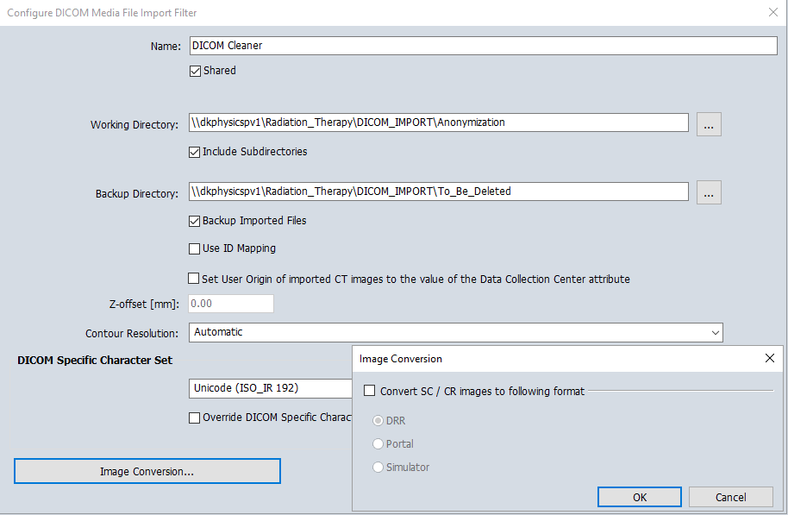

## External Plan Import

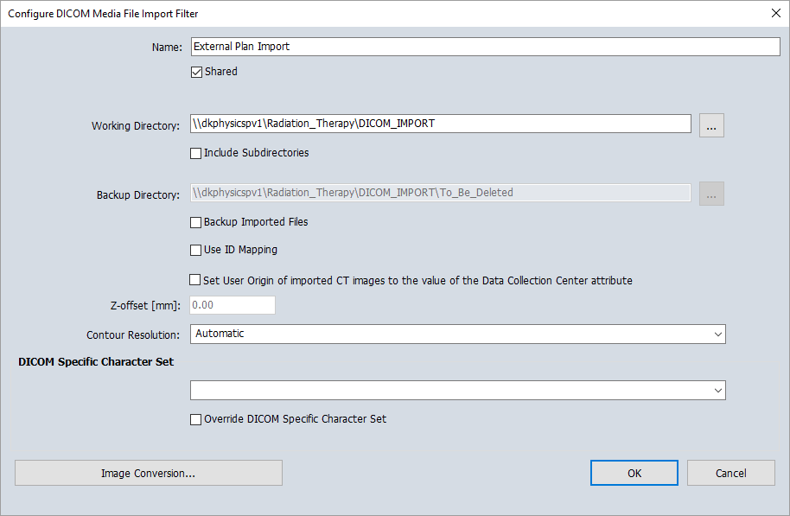

## GE Discovery RT – change to VMSFSD?

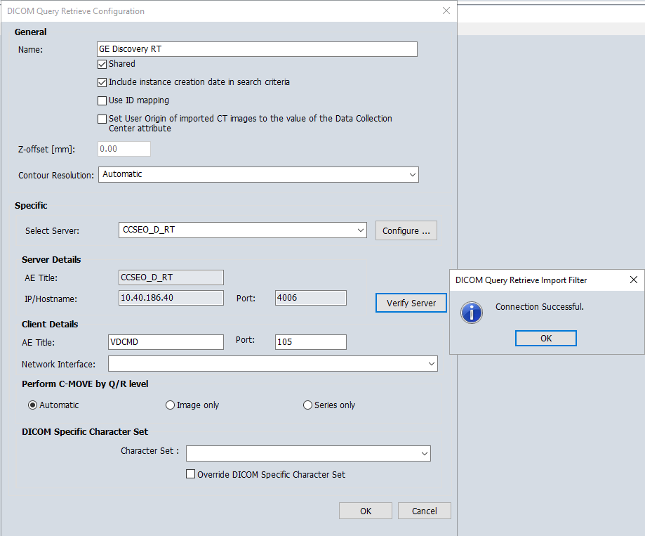

Does this need to change to VMSFSD? We are not using this query for CT import at the moment.

# EXPORT FILTERS

## Physics QA Images

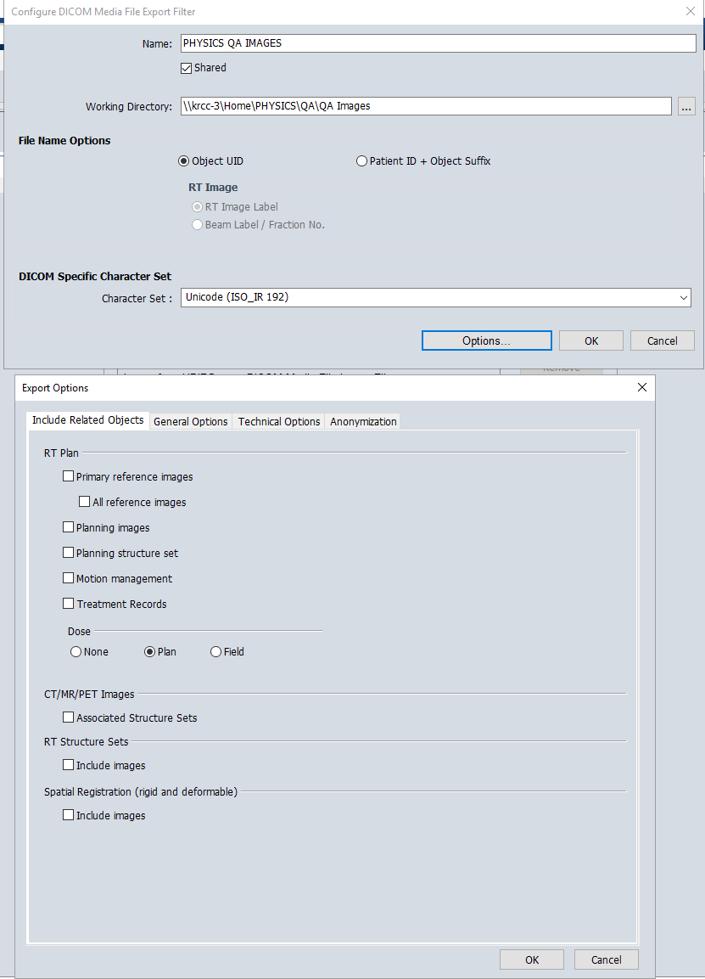

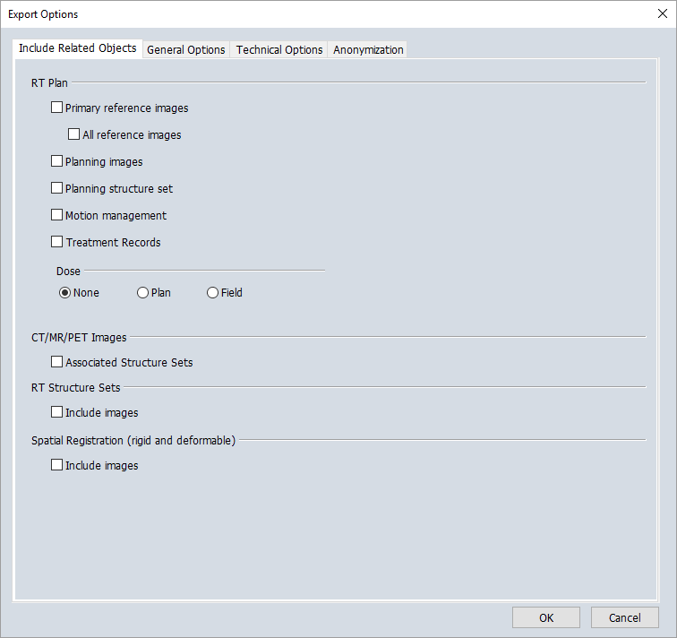

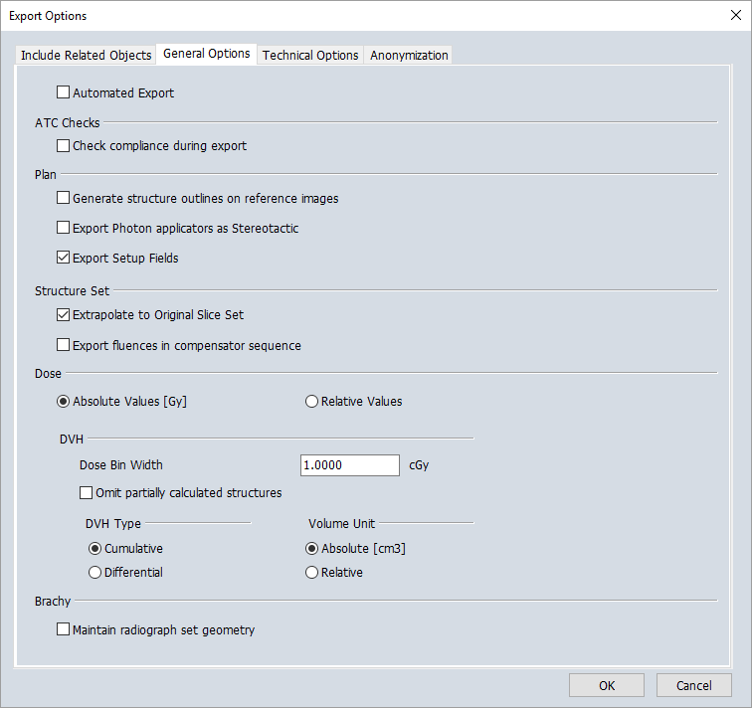

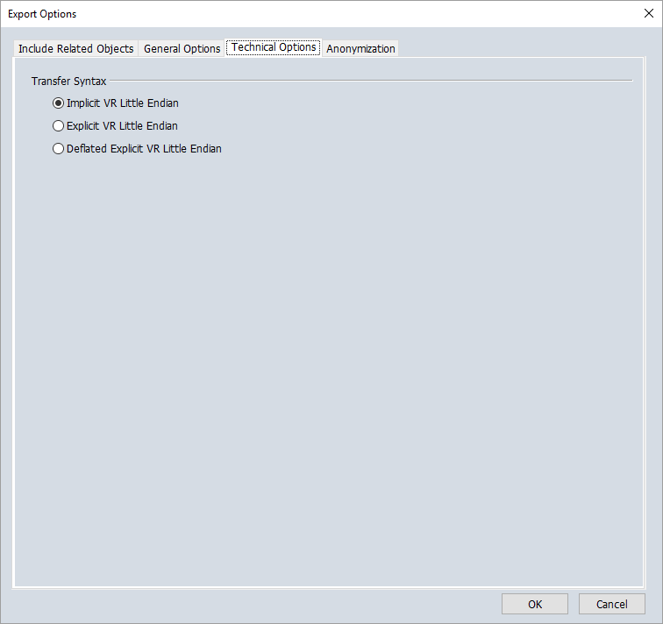

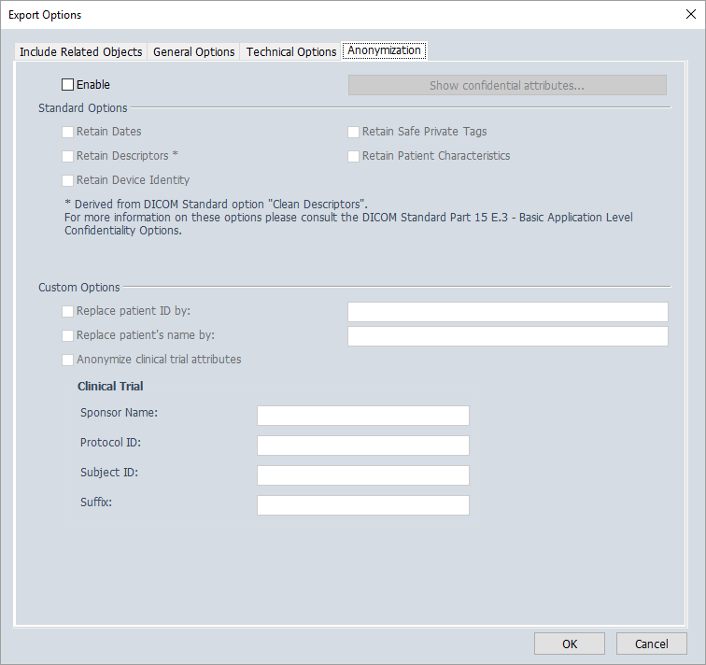

## DICOM Export to HDR

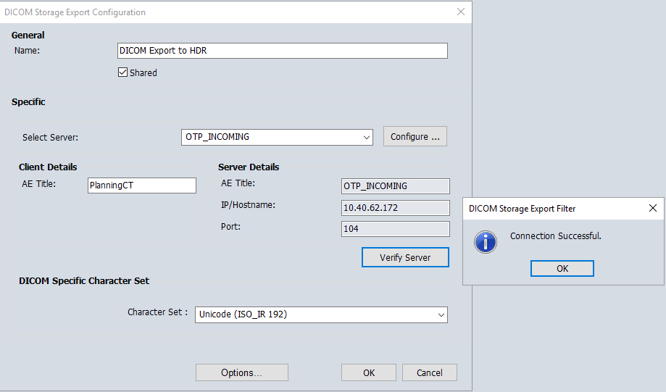

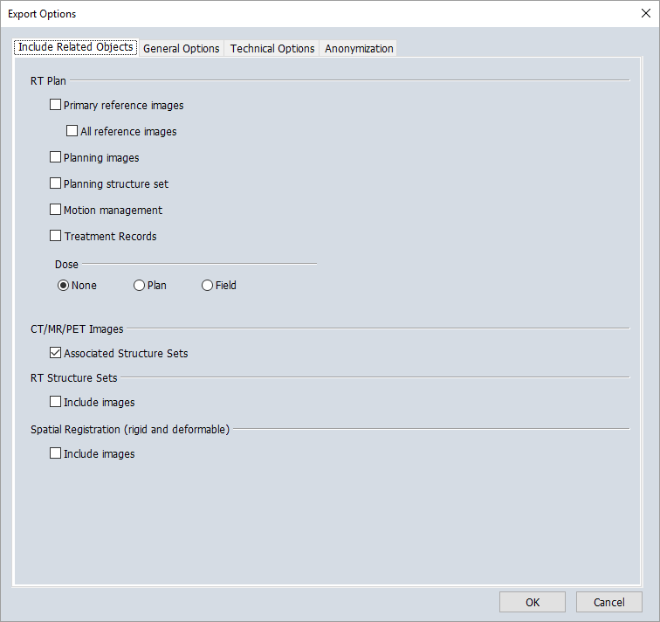

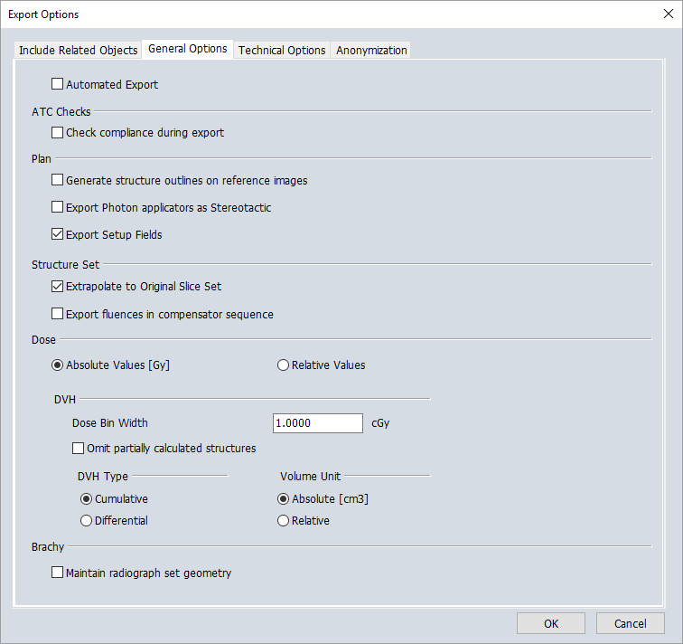





## DICOM CLEANER

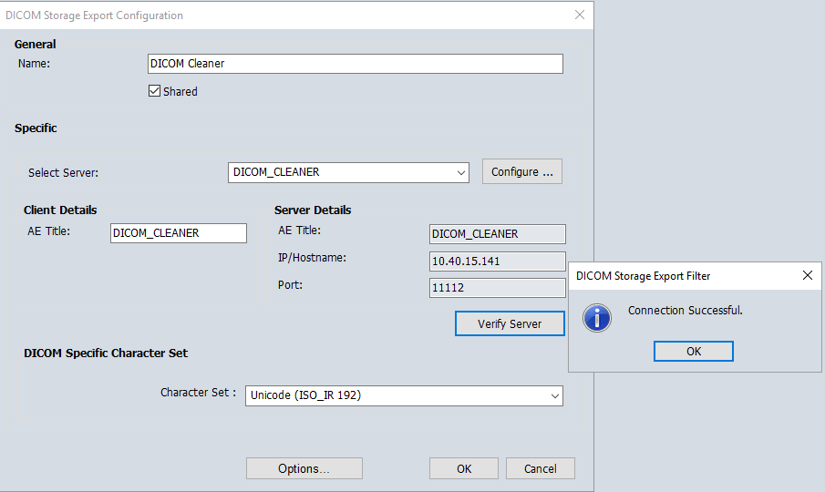

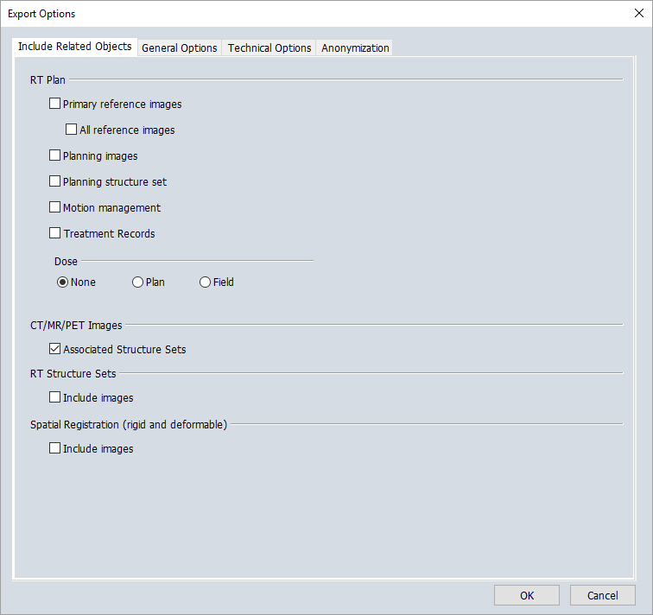

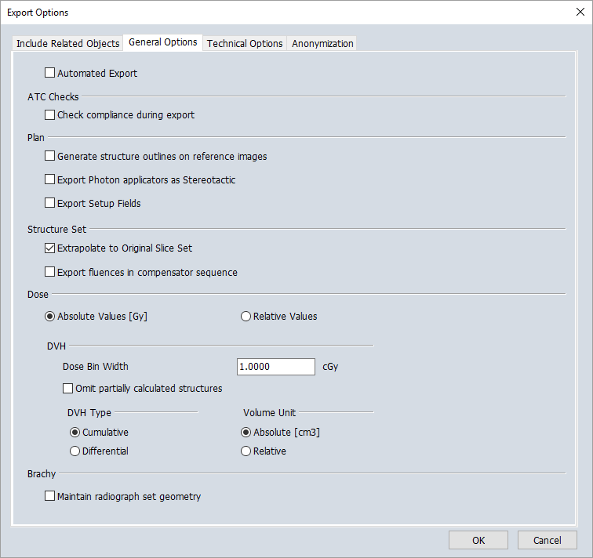

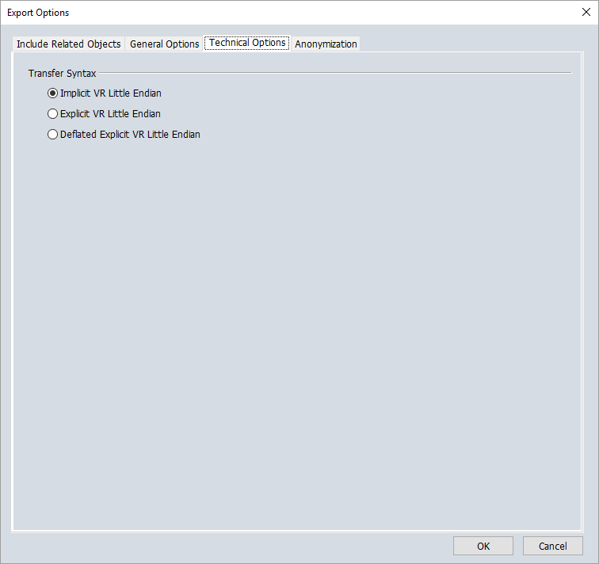

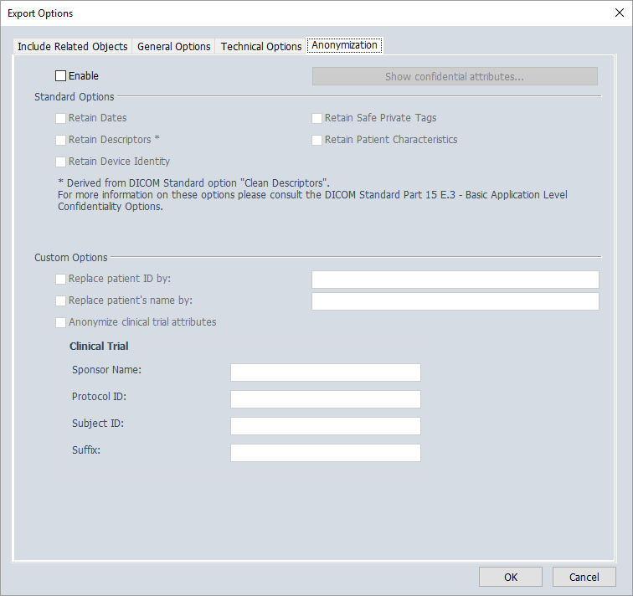

## Velocity Grid

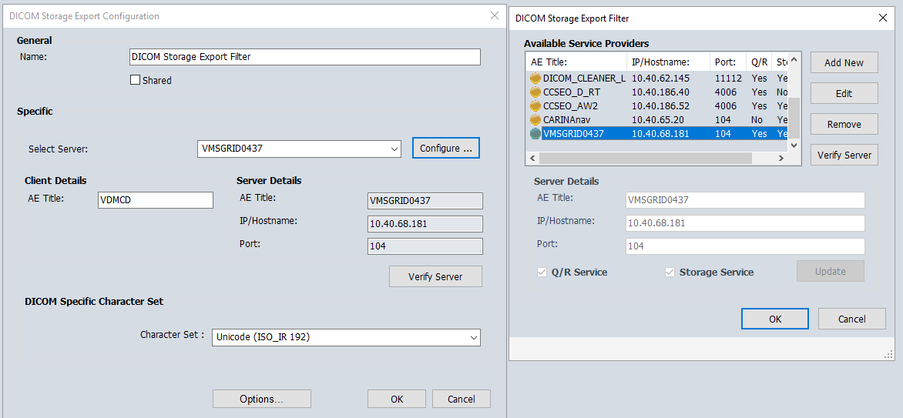

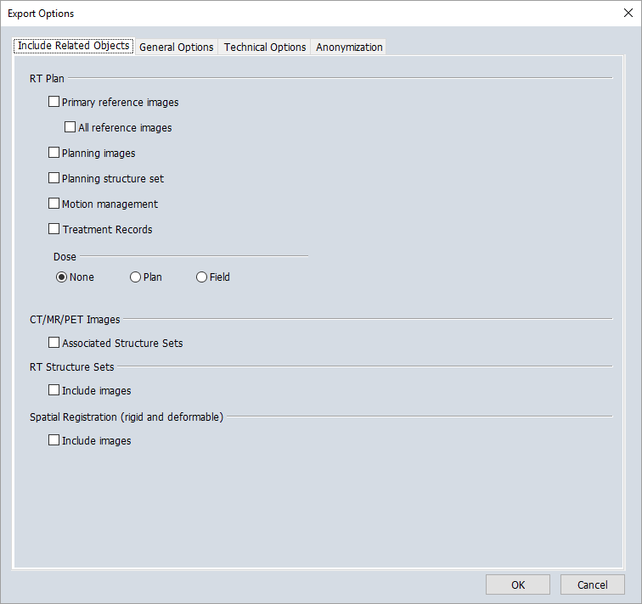

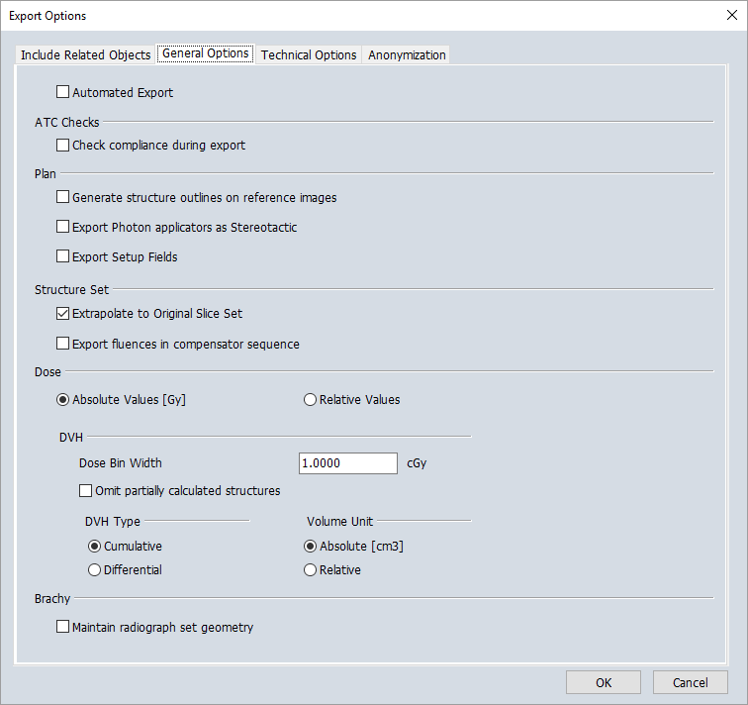

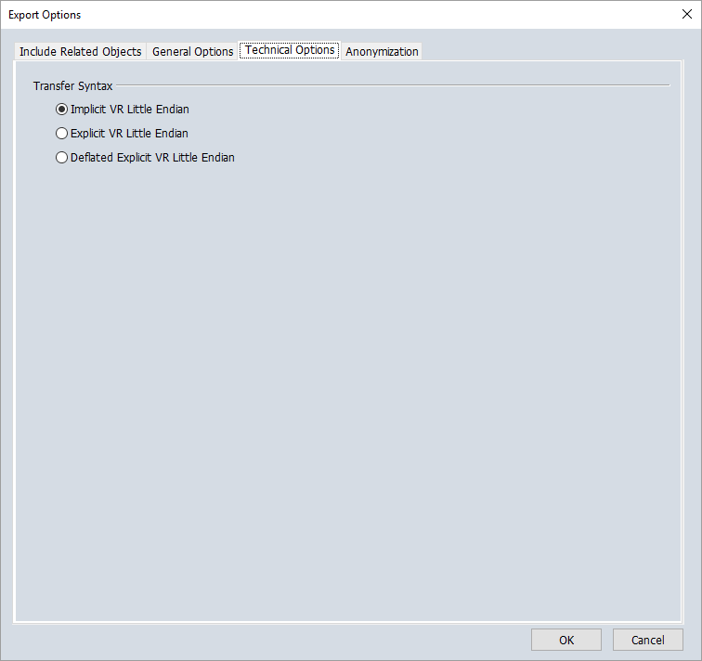

## VelocitySend

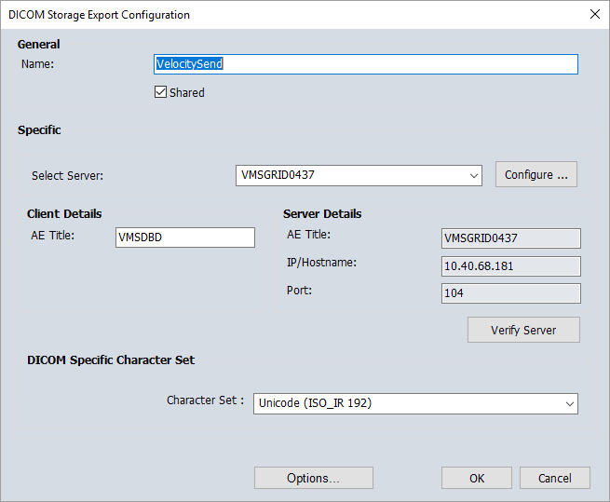

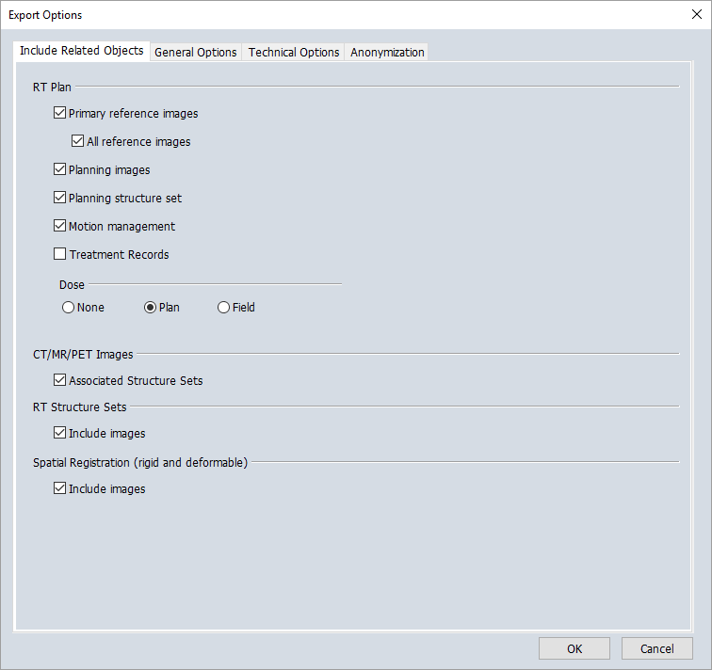

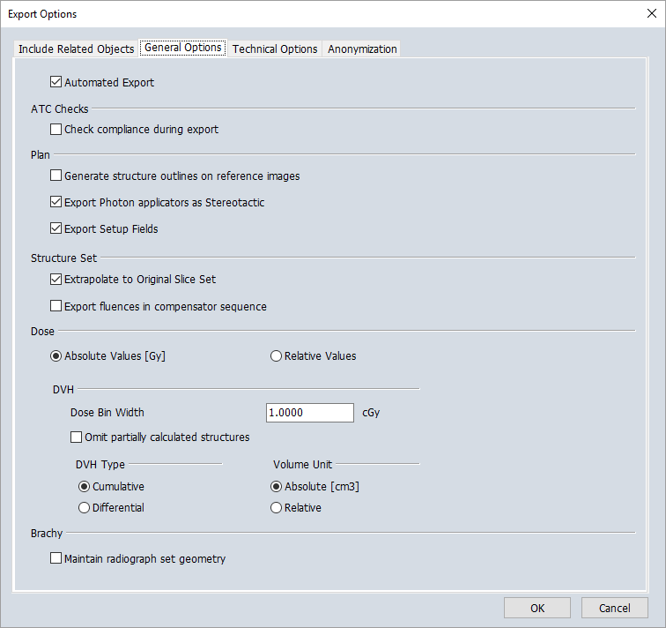

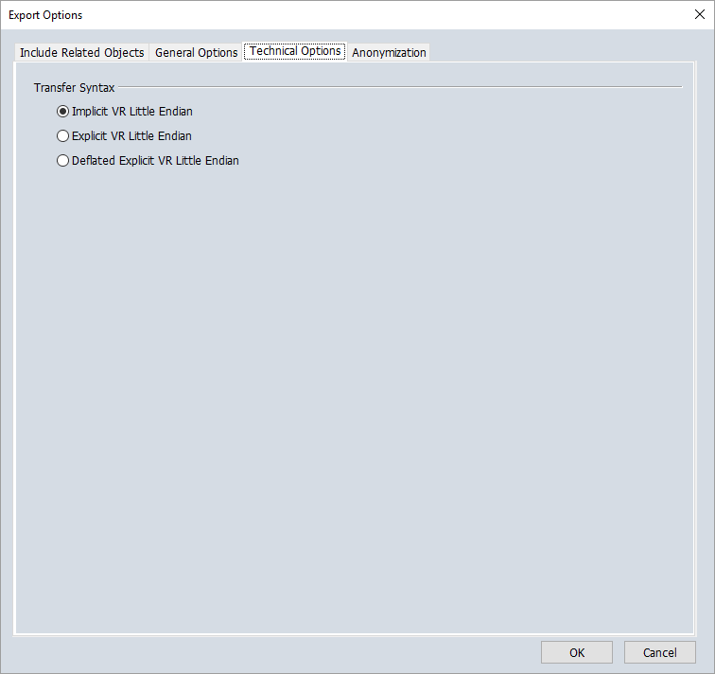

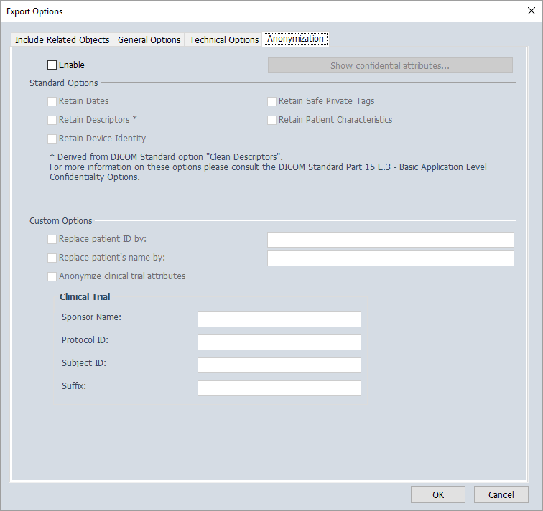

## QA Images

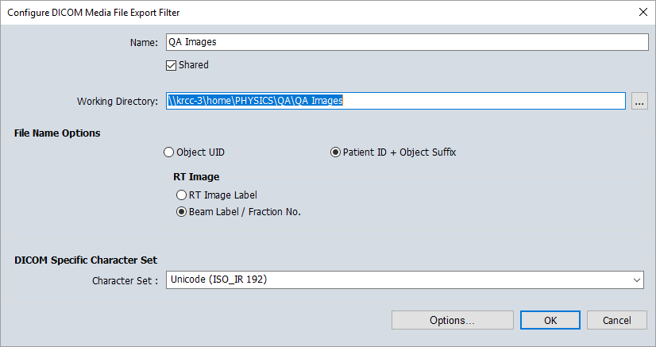



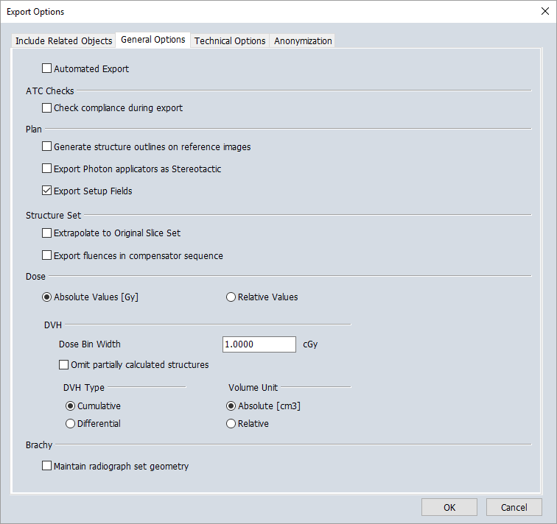

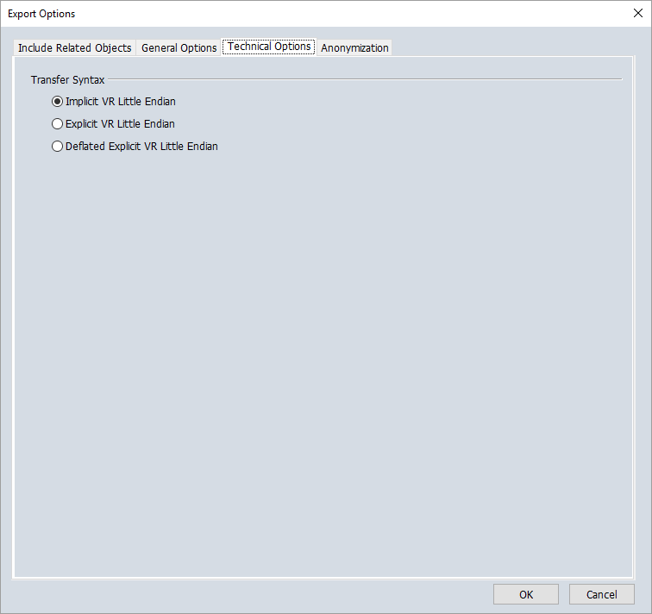



## Export for Anonymization

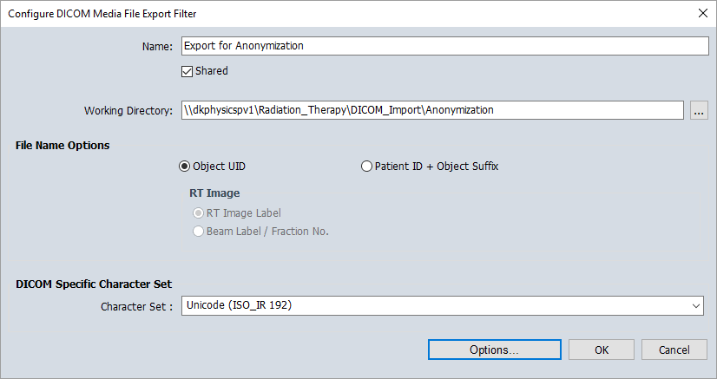

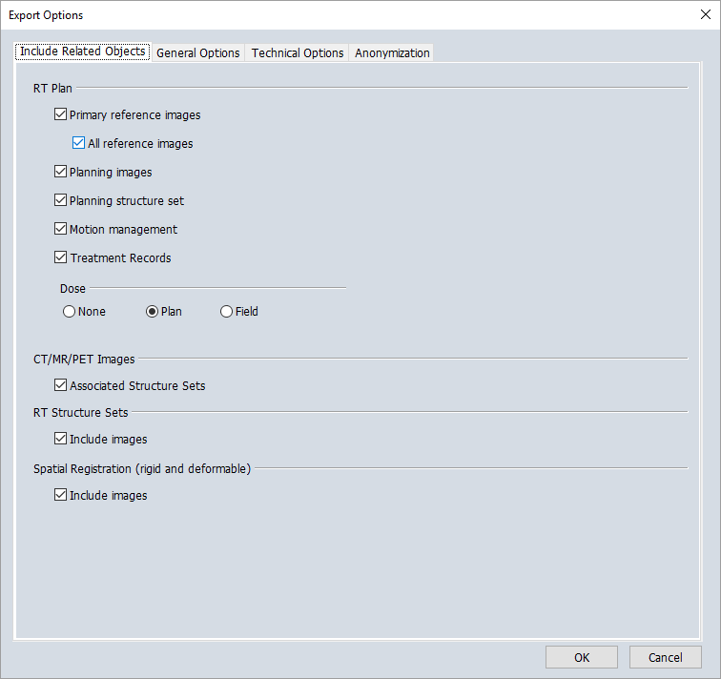

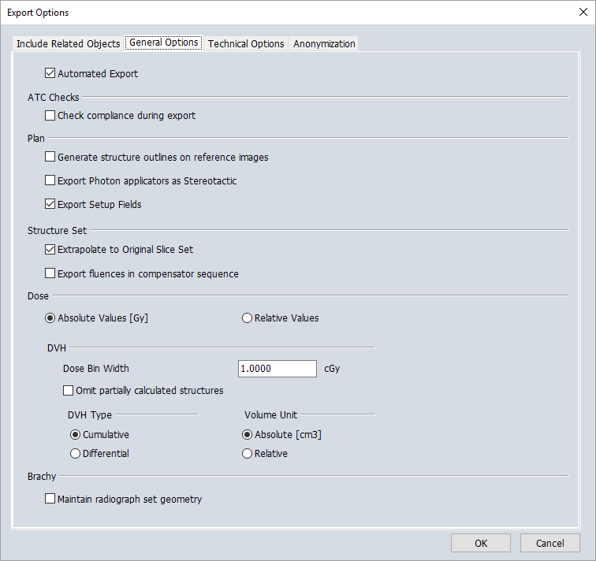





## KGH PACS (?)

## Advantage Workstation AW2

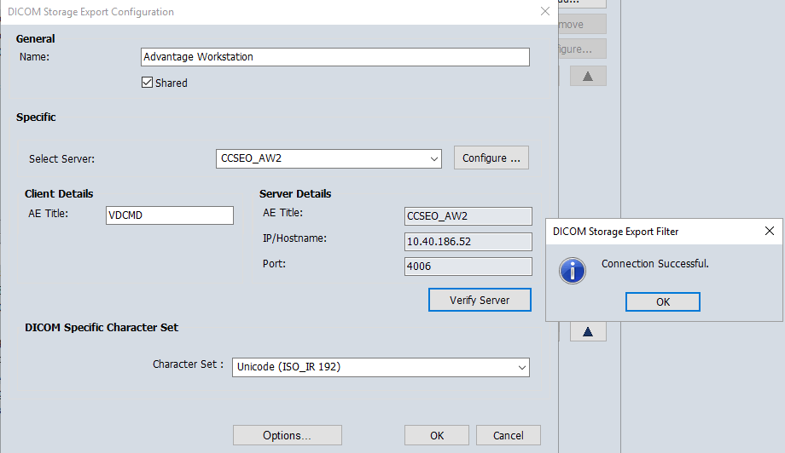



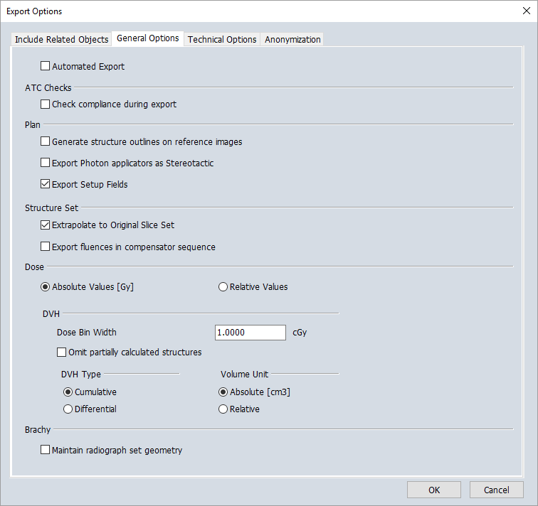

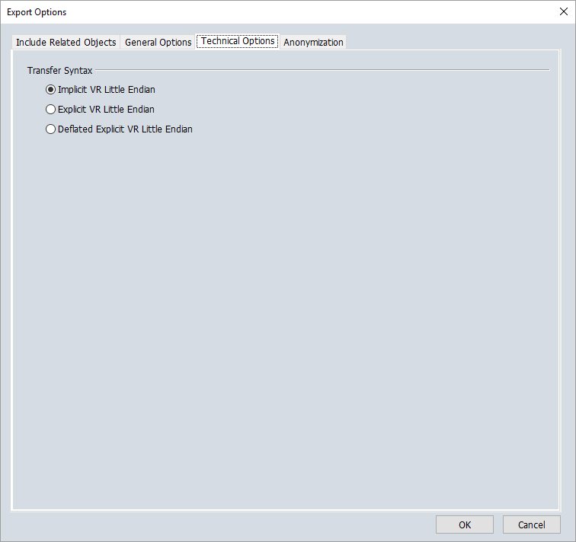

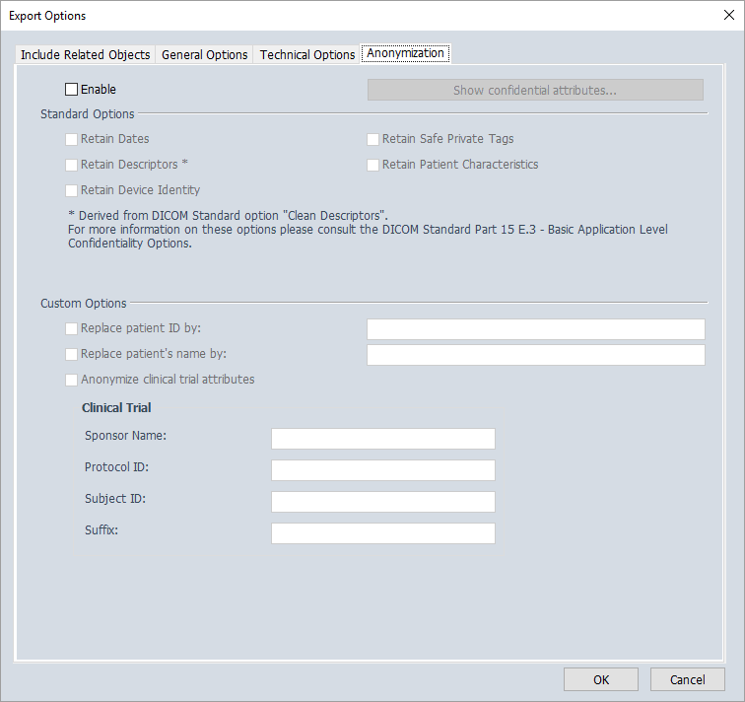

## LAP Laser Export (?)

## Export to IMSURE

